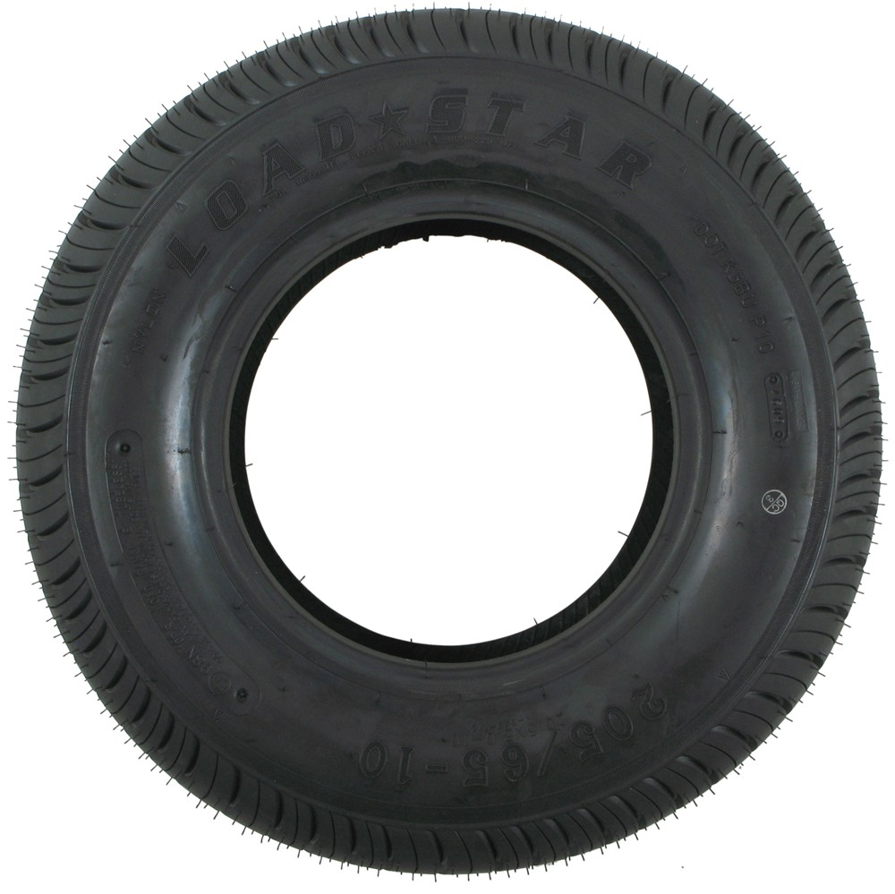

**FREE Tire**

**Recycling!**

**February 12th-18th, 2018**

***Rules***

* **No more than 9 tires per trip.**
* **No tires over 46 inches in diameter.**
* **No tires from tire**

**businesses.**

* **No bicycle**

**tires.**



***Location:***

**Mon-Sun: 9am-2pm**

**Location: Nicasio Corp Yard.**

**5575 Nicasio Valley Rd, Nicasio CA**

**94946**

**For more information:**

**Call (415) 454-4554**