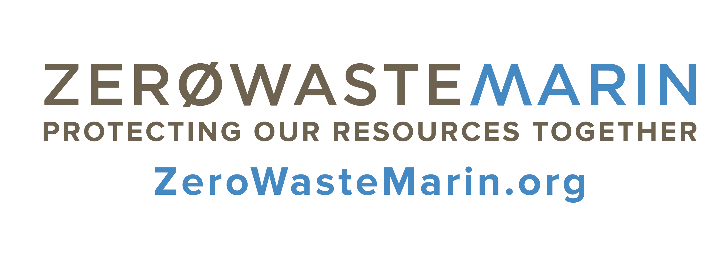

Household Hazardous Waste FAQs

Follow these helpful tips to safely dispose of household hazardous waste (HHW) in Marin County.

What is HHW?
Common household items such as fluorescent bulbs, batteries, gasoline, household chemicals, pesticides, paints, antifreeze and asbestos are all considered HHW. These items can be toxic to you and/or the environment and must be disposed of properly to protect you, the environment and your resource hauler. Learn more at Zero Waste Marin:
www.zerowastemarin.org/residents/household-hazardous-waste.

Where can I dispose of HHW in Marin County?
Marin Household Hazardous Waste Facility (All Marin residents and businesses except Novato)
www.marinhhw.com
565 Jacoby St. San Rafael, CA 94901
(415) 485-6806
Open Tuesday – Saturday, 8 a.m. – 3:30 p.m. Closed Sundays and Mondays.

Novato Recycling Center (Novato residents and small businesses only)
www.novatosan.com/green/recycling-and-hazardous-waste-disposal-resources
7576 Redwood Blvd. Novato, CA 94945
(415) 892-7344
Open the 1st and 3rd Sunday and Monday of each month from 8:30 a.m. – 1:30 p.m.

How can I get rid of bulbs and batteries?
Zero Waste Marin’s Bulb and Battery Take-Back Program helps residents recycle light bulbs and batteries at no charge at participating locations. Visit ZeroWasteMarin.org/bulb to find a location near you.

Zero Waste Marin works with cities and towns throughout Marin County to help residents and businesses safely dispose of HHW. For more information please visit our website ZeroWasteMarin.org
ZeroWasteMarin.org | (415) 473-6647

